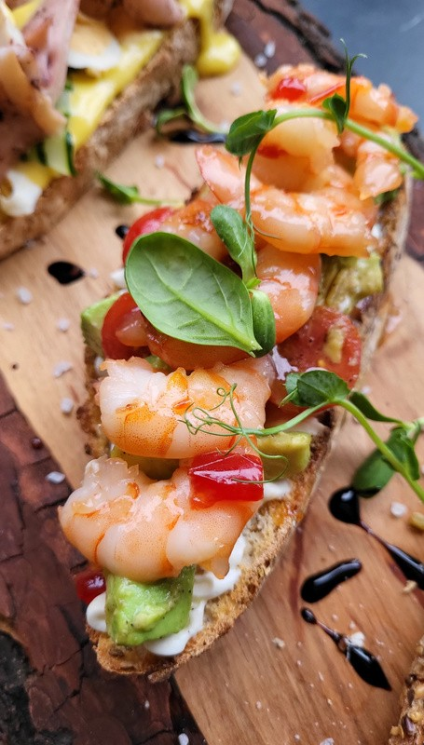



B R U S C H E T T A

# with shrimps

Ingredients:

8 slices of French bread baguette 1/4 cup olive oil

1 garlic clove

1 pound medium-sized shrimp Salt and pepper, to taste

Fresh basil, chopped Parmesan cheese, grated

# Directions:

Preheat oven to 400°F (200°C). Brush baguette slices with olive oil and toast in the oven for 5-7 minutes.

In a skillet, fry minced garlic in 2 tbsp of olive oil. Add shrimp, season with salt and pepper.

Remove the skillet from heat and stir in chopped basil.

Top each baguette slice with the shrimp mixture, and grated Parmesan cheese.

Enjoy!