

Event Press Release

LERNERRA [www.reallygreatsite.com](http://www.reallygreatsite.com/)

Lernerra to Host Webinar Event on

"AI for Education" on July 9

MM/DD/YYYY

ANY CITY, ST (PRESS RELEASE DISTRIBUTOR) - A good press release starts with a strong lead paragraph. What is the most important thing the reader needs to know? Write 2-3 sentences about the who, what, when, where, and why of your event here.

The goal of a press release is to generate media coverage and increase visibility for your event. Use the next 1-2 paragraphs to discuss your event's details, such as location, date, time, ticket prices, and accessibility considerations for those with special needs.

Include highlights, notable guests or speakers, and other newsworthy details.

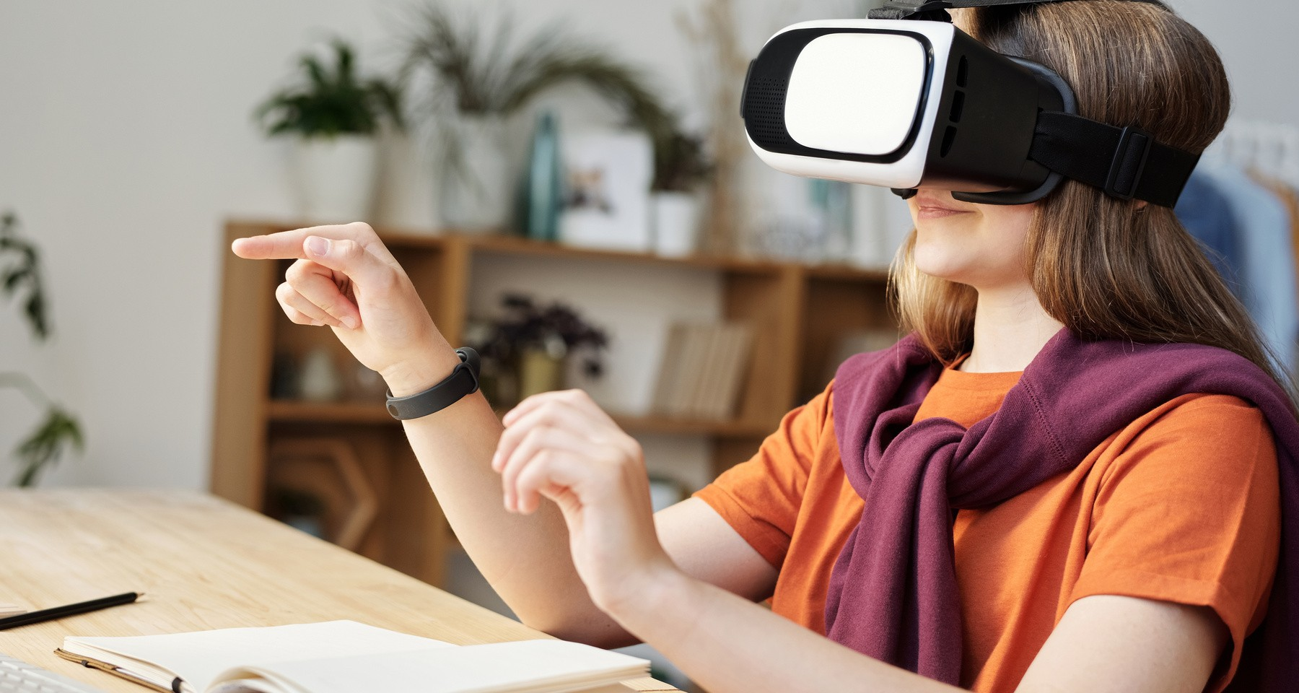

Include an official photo or visual material for the press

"You can also insert a quote or statement from key stakeholders to add interest and credibility to your press release."

End your press release with a clear call to action. You may add hyperlinks to lead the audience to sign up for your event.

Webinar Event Details

July 9, 2030

10:00 AM EST

International: +123-456-7890

Webinar Link: [www.reallygreatsite.com](http://www.reallygreatsite.com/)



About Lernerra

Share information about the company here. Include details such as its headquarter location, products, services, and customers. You may also add the company's vision, mission, and targets.

Analyst or Media Contact

Elvira Montanez

123-456-7890

[hello@reallygreatsite.com](mailto:hello@reallygreatsite.com)