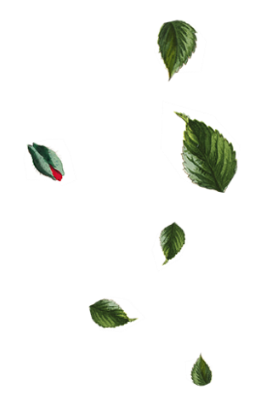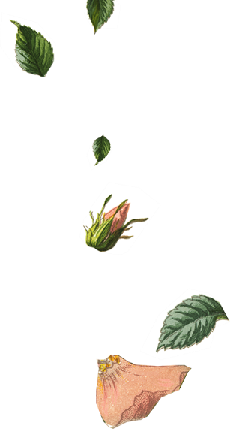

|  |  |  |  |  |
| --- | --- | --- | --- | --- |
|  | You are invited to join |  |  |  |
| Robin Zupanc  Peyton Davis |  |  |  |
| & | |  |
|  |  |  |
| on our wedding day | |  |  |
|  | You are invited to join |  |  |  |
| Robin Zupanc  Peyton Davis |  |  |  |
| & | |  |
|  |  |  |
| on our wedding day | |  |  |

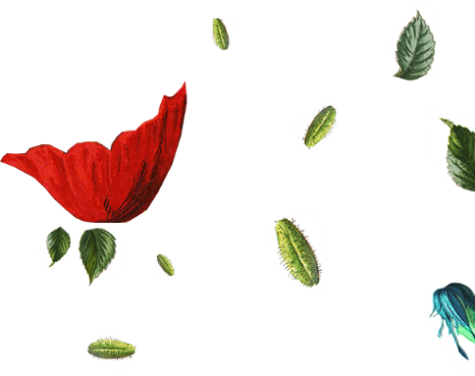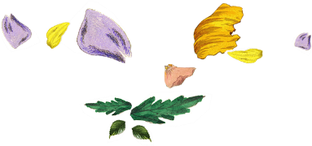

|  |  |
| --- | --- |
|  | Mr. & Mrs. Robin Zupanc  Request the honor of Your Presence  At the marriage of Robin Zupanc To Peyton Davis Child of  *Mr. & Mrs.* Peyton Davis Saturday the Twenty-First of JuneTwo thousand and [Year]Eleven O’clock in the morningAt Location City, State.Reception to Follow |
|  | Mr. & Mrs. Robin Zupanc  Request the honor of Your Presence  At the marriage of Robin Zupanc To Peyton Davis Child of  *Mr. & Mrs.* Peyton Davis Saturday the Twenty-First of JuneTwo thousand and [Year]Eleven O’clock in the morningAt Location City, State.Reception to Follow |