Chocolate Cake

Prep Time : Cook Time : Servings :

*Chocolate cake is simple cake made with simple ingredient. You can make it with an easy recipe below*

***INflREDIENTS PROCEDURE***

1. cups of awesome 1/2 tsp of fun
2. tbsp color

1 cup of kindness

salt and pepper to taste

1. Mix awesome and fun together.
2. Add a dash of color.
3. Flavor everything with kindness!

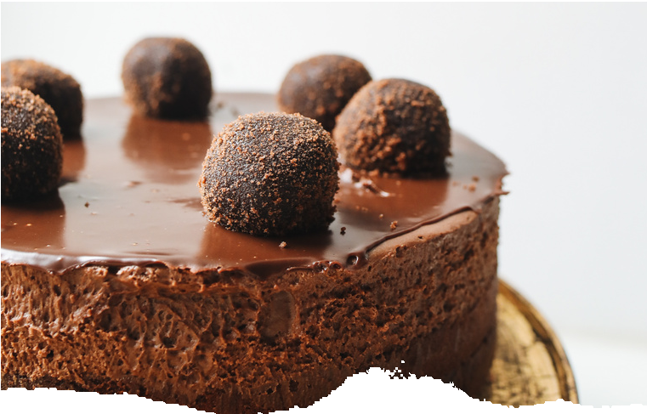

**NOTES :**

Enjoyed best when shared.