Honey Bundt Cake



May your new year be as sweet as this cake!

# Ingredients

1 kg main ingredient 11/12 L superior spice 2 Tbsp secret sauce 1/4 C garnish

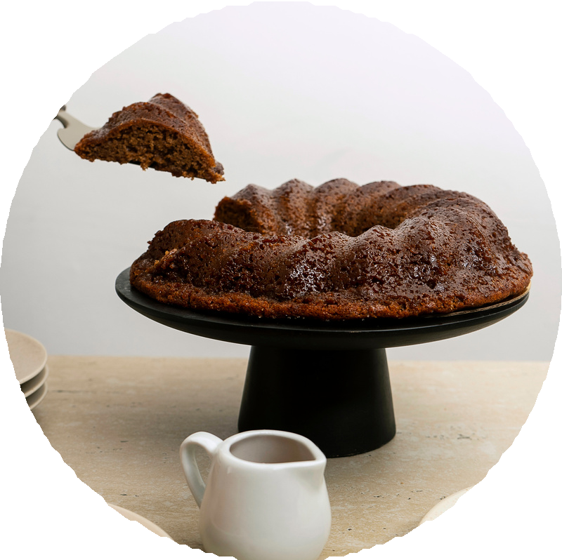

A dash of seasoning

# Directions

1. Combine ingredients in a large bowl.
2. Add seasoning and cook over low heat
3. Transfer to a serving dish to share and anjoy!