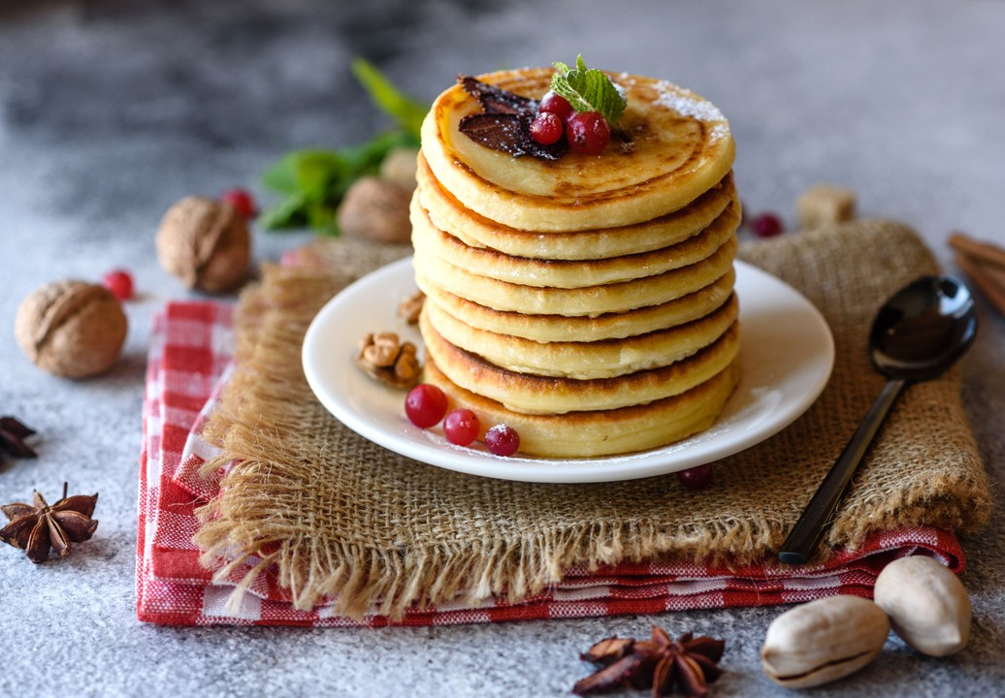

PANCAKE RECIPE

Ingredients:

1. *cup all-purpose flour 2 tablespoons sugar*
2. *teaspoons baking powder 1/2 teaspoon salt*

*1 cup milk*

1. *egg*
2. *tablespoons vegetable oil*

# Instructions:

1. In a bowl, mix together flour, sugar, baking powder, and salt.
2. In a separate bowl, beat together milk, egg, and vegetable oil.
3. Pour the wet ingredients into the dry ingredients and mix until just combined.
4. Heat a non-stick pan or griddle over medium heat.
5. Pour 1/4 cup of batter onto the pan for each pancake.
6. Cook until bubbles form on the surface, then flip and cook for an additional 1-2 minutes.
7. Repeat with remaining batter.
8. Serve with butter and syrup, or your favorite toppings. Enjoy!