Creamy Pasta

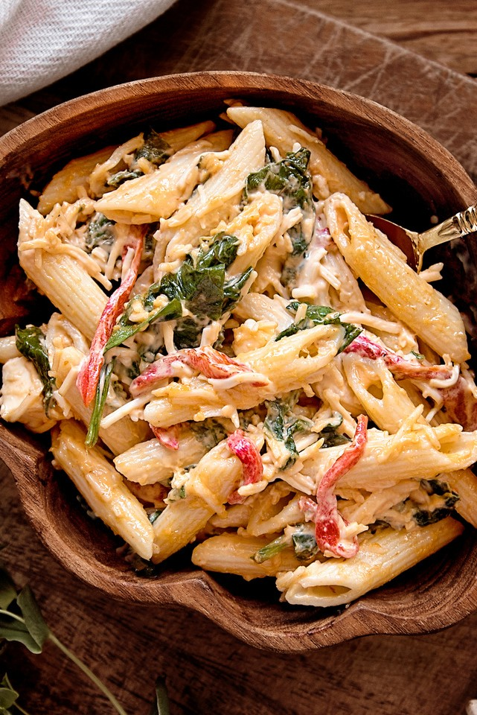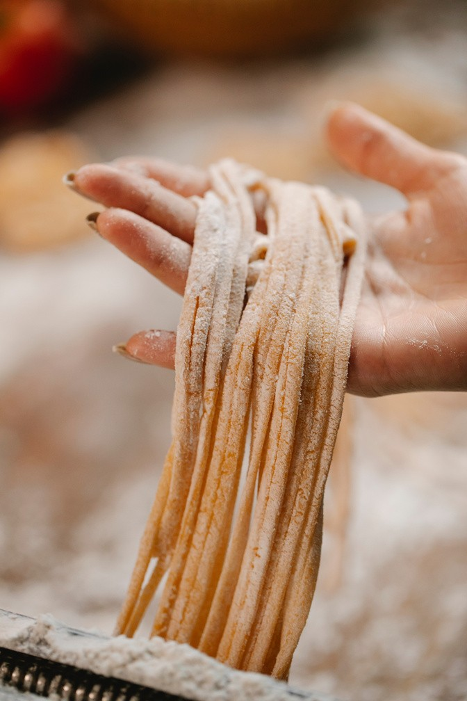

2 servings 15 minutes

# INGREDIENTS

100 ml milk

50 g butter

3 eggs

1 tbs cocoa

2 tsp baking soda a pinch of salt

3 eggs

# DIRECTIONS

1. Nunc nulla velit, feugiat vitae ex quis, lobortis porta leo.
2. Donec dictum lectus in ex accumsan sodales. Pellentesque habitant morbi tristique.
3. Nunc nulla velit, feugiat vitae ex quis, lobortis porta leo. Donec dictum lectus in ex. lentesque habitant morbi tristique. Nunc nulla velit, feugiat vitae ex quis, lobortis porta leo. Donec dictum lectus in ex.
4. Habitant morbi tristique.Nunc nulla velit, '